**Tuning Profile**

1. Check machine IP-



2. Install tuned package-



3. Start & enable tuned service-

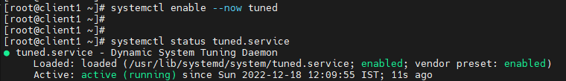

4. Long list tuned configuration files in etc directory-

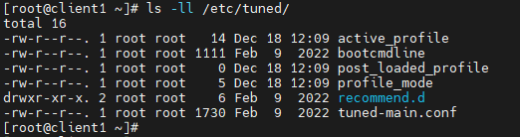



5. List all tuning profiles directory-

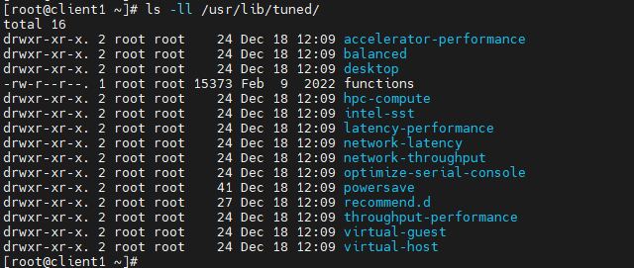

6. To check current active profile-



7. To check all available profiles-

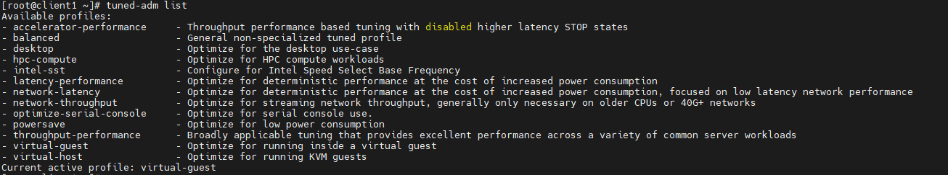

8. To set and verify a tuning profile from this list-

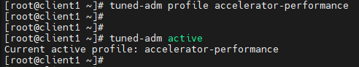

9. To check recommended tuning profile & apply it-

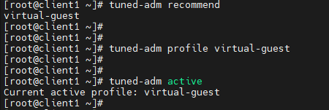

10. To turn off tuning profile-

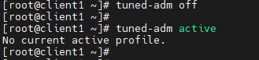

11. To create a custom tuning profile, we can create it in any directory, but in this case, we are creating in default directory-

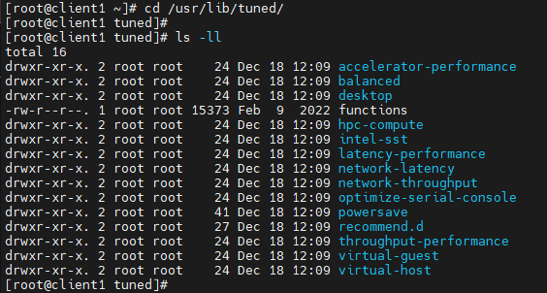

12. Create a directory & tuned.conf file in it-



13. Add below lines in this tuned.conf file-



14. Now, check all available tuning profiles-

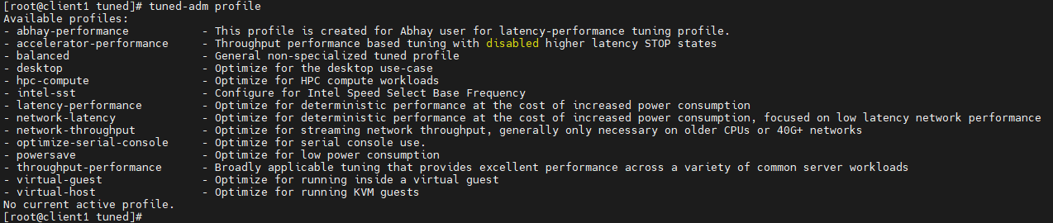

Here, we have our newly created tuning profile.

15. To set & verify this newly created tuning profile as the default one-

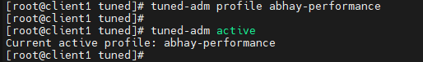

16. Now, we will create another custom tuning profile & this time in different location-



17. Edit the tuned.conf file with following lines-

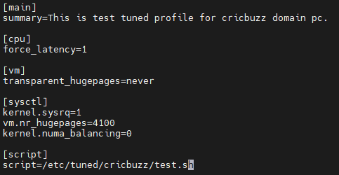

18. Make it executable as we are using script-



19. Now, check all available tuning profiles-

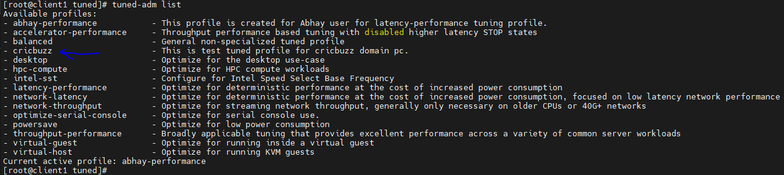

20. To set & verify this newly created tuning profile as the default one-

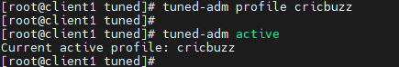

21. To check whether it is working or not-



Here it is showing transparent_hugepage as never, which we have defined in its tuned.conf file.

So, it is working perfectly fine!!!!!!